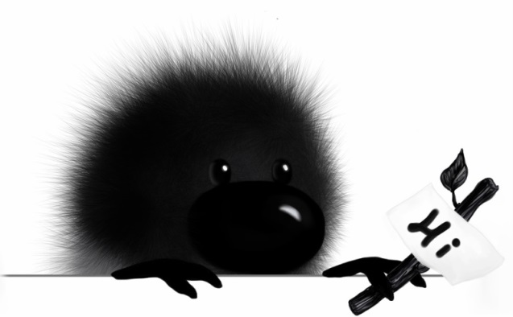Find the hidden words!
M | L | C | Q | N | O | N | M | A | F | B | F | F | O | L
C | U | Y | K | L | M | W | L | A | R | R | O | W | I | O
W | I | E | D | U | P | E | S | K | U | G | Y | H | F | E
X | B | H | T | I | E | G | E | X | Q | L | L | D | B | R
D | S | U | K | K | A | Y | N | N | X | D | L | B | R | F
N | A | H | Z | N | E | D | G | Z | Y | V | O | J | H | J
A | A | Y | H | E | F | X | Y | L | I | E | O | Y | K | T
E | I | M | K | I | W | P | Q | W | M | D | W | N | J | X
J | L | S | R | L | T | K | A | K | S | Y | L | D | O | J
F | V | Q | R | E | Z | U | G | Q | W | Y | Q | M | X | O
X | M | Q | F | N | V | D | G | U | U | J | P | A | T | Z
S | Z | C | N | P | B | A | S | F | C | D | D | H | B | W
J | N | W | K | B | V | D | R | H | R | M | Q | M | H | J
M | Y | D | G | Q | D | Y | X | B | O | X | E | W | F | T
N | A | I | R | A | T | E | G | E | V | M | S | G | Z | U

ANSWERS:

ARROW | AUTUMN | BRAVERMAN
LEE | YDIA | NEIL
VEGETARIAN | WOOLLY

Copyright Annie’s Art Book, 2013
http://woollybook.com,

